**Jump Statements**

There are three types of the jump statements in the java

1. Continue Statement
2. Break Statement
3. Return Statement

🡪**Continue statement** is often used inside the programming language inside the loops control structures. Inside the loop, **When a continue statement is encountered the control directly jumps to the beginning of the loop for the next iteration instead of executing the statement of the current iteration.**

🡪The continue statement is used when we want to skip a particular condition and continue the rest execution. Java continue statement is used for all type of loops but it is generally used in for, while, and do-while loops.

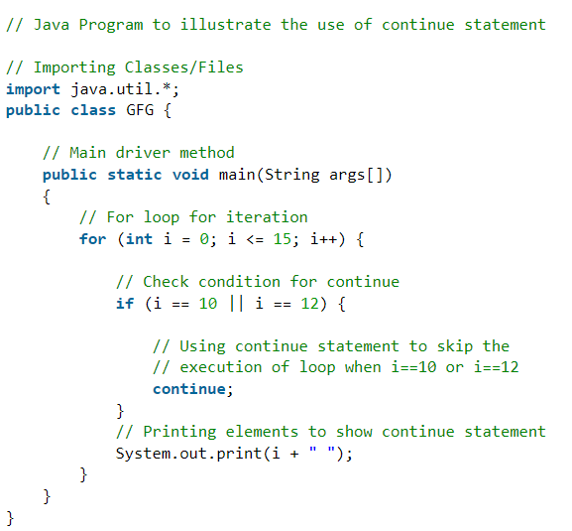

🡪**Break Statement** is a loop control statement that is used to terminate the loop. As soon as the break statement is encountered from within a loop, the loop iterations stop there, and control returns from the loop immediately to the first statement after the loop.

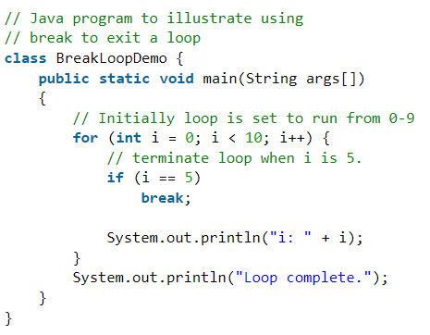

🡪In Java, **return**is a reserved keyword i.e, we can’t use it as an identifier. It is used to **exit** from a method, with or without a value. Usage of **return keyword** as there exist two ways as listed below as follows:

* **Case 1:** Methods returning a value
* **Case 2:** Methods not returning a value

**🡺Case 1:**

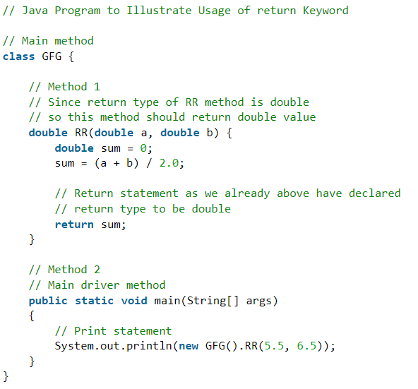

**🡺Case 2:**

